The 2015 Michigan Lean Consortium Conference:

“2015 – Transforming The Future NOW”

Dates: August 11, 2015, (optional pre-event spirits tasting)

August 12-13, 2015 (official conference days)

August 14, 2015, (optional post conference workshops)

Location: The Hagerty Center at Northwestern Michigan College
715 E. Front St
Traverse City, MI 49686
Look for Signs: Great Lakes Campus; McManus Archway

Who Should Attend: Those who strive to transform Michigan’s businesses and governments by sharing lessons learned, being innovative and employing transcending concepts with the utilization of customer focus mentality, exemplary leadership and experimentation.

Evening of August 11th
5:30 – 7:00 PM Optional evening networking event at Grand Traverse Distillery
(additional $20.00 fee applies – pre-registration required)
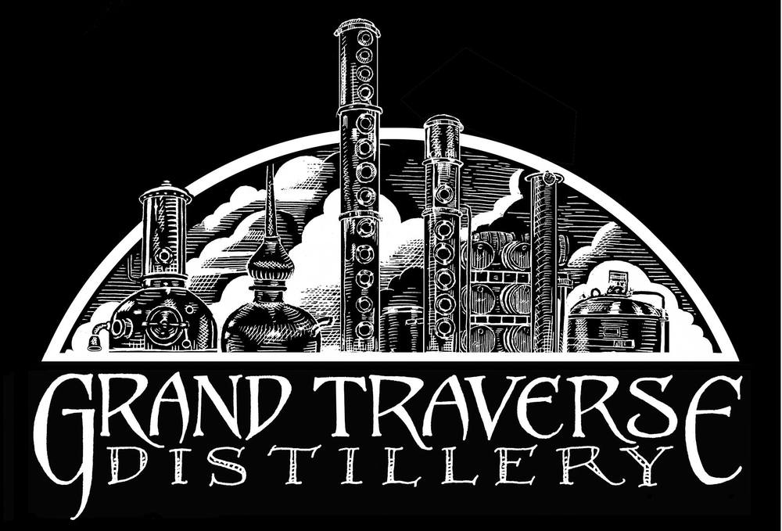
Located at 781 Industrial Cir #5, Traverse City, MI 49686 (231) 947-8635, you will be able to taste spirits, tour the facility and taste cheese from The Cheese Lady for only $20! This is a great chance to network and meet new people before the conference begins on Wednesday.

Day 1: Wednesday, August 12

7:30 - 9:15 AM Check-in Opens & Continental Breakfast
9:15 - 9:30 AM Conference Welcome & Opening Comments
9:30 - 10:30 AM Keynote Speaker Darrell Rogers-“Sociology of Success”
10:35 - 12:30 PM Breakout Sessions
12:30 - 1:30 PM Lunch & Networking
1:30 - 3:30 PM Breakout Sessions
3:30 - 3:45 PM Break
3:45 - 4:45 PM Networking Session
4:45 - 5:00 PM Day 1 Reflection, Giveaways & Announcements
5:00 - 6:15 PM Reception-Hors Devours + Cash Bar
6:15 - 6:45 PM Nature Walk hosted by the MLC Young Professionals Group

Day 2: Thursday, August 13
8:00 - 9:00 AM | Continental Breakfast & Networking
9:00 - 10:00 AM  10:00- 10:15 AM | Keynote Speaker Richard Sheridan-“Chief Storyteller (CEO)” Menlo Innovations  Break
10:15 -12:15PM | Breakout Sessions
12:15 - 2:00PM | Lunch & Keynote Speaker Mike Zimmer-“Reinventing the Reinvention Platform”-Transforming State Government
2:00 – 2:15PM  2:15 - 4:15PM | Break  Breakout Sessions
4:15 - 4:45PM | Day 2 Reflection, Awards & Giveaways – Conference End
Day 3: Friday, August 14-Optional Workshops
additional fee applies
$20.00 for full conference attendees
$99.00 if only attending workshop

7:30 - 8:15 AM Continental Breakfast & Networking
8:15 – 12:15 PM Workshop-Option 1
Red Bead Redux Featuring the Funnel Experiment
Facilitators-Gerald Browne & Jim Manley
Workshop-Option 2
Extraordinary Leadership-Fundamentals of Success
Facilitator-Dennis Sergent

